***“*Develop A Smart Attendance Capturing Mobile App*”***

**A Project Report Submitted to**

**Rajiv Gandhi Proudyogiki Vishwavidyalaya**

**Towards Partial Fulfillment for the Award of**

**Bachelor of Engineering in Computer Science Engineering**

***Submitted by:***

***Guided by:***

**Shubham Patel(0827CS201237)**

**Sarwesh lowanshi(0827CS201219)**

**Shivam Chouhan (0827CS201228)**

**Vikash Rawat(…………………………..)**

**Dr. ……………………**

**Professor, CSE**

**AITR, Indore**



***Acropolis Institute of Technology & Research, Indore***

**July - Dec 2022**

EXAMINER APPROVAL

The Project entitled ***“*Develop A Smart Attendance Capturing Mobile App*”*** submitted by **Shubham Patel(0827CS201237), sarwesh lowanshi(0827CS201219),Shivam chouhan(0827CS201228),Vikash rawat(………)** has been examined and is hereby approvedtowards partial fulfillment for the award of ***Bachelor of Technology*** ***degree in Computer Science Engineering*** discipline, for which it has beensubmitted. It understood that by this approval the undersigned do not necessarily endorse or approve any statement made, opinion expressed or conclusion drawn therein, but approve the project only for the purpose for which it has been submitted.

**(Internal Examiner)** **(External Examiner)**

**Date:** **Date:**

GUIDE RECOMMENDATION

This is to certify that the work embodied in this project entitled **“Develop A *Smart Attendance Capturing Mobile App* ”**submitted by **Shubham Patel(0827CS201237), sarwesh lowanshi(0827CS201219),Shivam chouhan(0827CS201228),Vikash rawat(………)**is asatisfactory account of the bonafide work done under the supervision of ***Ankit Jain***, is recommended towards partial fulfillment forthe award of the Bachelor of Technology (Computer Science Engineering) degree by Rajiv Gandhi Proudyogiki Vishwavidhyalaya, Bhopal.

**(Project Guide)** **(Project Coordinator)**

STUDENTS UNDERTAKING

This is to certify that project entitled ***“*Develop A *Smart Attendance Capturing Mobile App”*** has developed by us under the supervision of ***Antik Jain***. The whole responsibility of work done in this project is ours.The sole intension of this work is only for practical learning and research.

We further declare that to the best of our knowledge; this report does not contain any part of any work which has been submitted for the award of any degree either in this University or in any other University / Deemed University without proper citation and if the same work found then we are liable for explanation to this.

**Shubham Patel(0827CS201237)**

**Sarwesh lowanshi(0827CS201219)**

**Shivam Chouhan (0827CS201228)**

**Vikash Rawat(…………………………..)**

Acknowledgement



We thank the almighty Lord for giving me the strength and courage to sail out through the tough and reach on shore safely.

There are number of people without whom this projects work would not have been feasible. Their high academic standards and personal integrity provided me with continuous guidance and support.

We owe a debt of sincere gratitude, deep sense of reverence and respect to our guide and mentor **Ankit Jain,** Professor, AITR, Indore for his motivation, sagacious guidance, constant encouragement, vigilant supervision and valuable critical appreciation throughout this project work, which helped us to successfully complete the project on time.

We express profound gratitude and heartfelt thanks to **Dr. Kamal Kumar Sethi**, Professor & Head CSE, AITR Indore for his support, suggestion, andinspiration for carrying out this project. I am very much thankful to other faculty and staff members of IT Dept, AITR Indore for providing me all support, help and advice during the project. We would be failing in our duty if do not acknowledge the support and guidance received from **Dr S C** **Sharma**, Director, AITR, Indore whenever needed. We take opportunity toconvey my regards to the management of Acropolis Institute, Indore for extending academic and administrative support and providing me all necessary facilities for project to achieve our objectives.

We are grateful to **our parent** and **family members** who have always loved and supported us unconditionally. To all of them, we want to say “Thank you”, for being the best family that one could ever have and without whom none of this would have been possible.

**Shubham Patel(0827CS201237), Sarwesh lowanshi(0827CS201219), Shivam chouhan (0827CS201228) Vikash rawat (……………….)**

Executive Summary



**Develop A *Smart Attendance Capturing Mobile App***

This project is submitted to Rajiv Gandhi Proudyogiki Vishwavidhyalaya, Bhopal (MP), India for partial fulfillment of Bachelor of Engineering in Information Technology branch under the sagacious guidance and vigilant supervision of ***Ankit Jain***.

The project is based on Machine Learning, concerned with algorithms inspired by the structure and function of the brain called artificial neural networks. In the project, TensorFlow is used, which is an open-source software library created by Google for machine learning applications. It is used for detecting, identifying and tracking objects through the camera in real time. The project uses a pre-trained model on Microsoft Common Objects in Context (COCO) data set , which contains approximately all common objects. The purpose of this project is to implement 'Students and vehicles counter' in the college in real-time.

**Key words** : Image Processing, Neural Networks, Tensorflow

*“Where the vision is one year, cultivate flowers;*

*Where the vision is ten years, cultivate trees;*

*Where the vision is eternity,*

*cultivate people.” - Oriental Saying*

Introduction



In current scenario, marking attendance in the company is the essential tasks of the record handlers. The management and maintenance of employee information is a key task for any company. it is not easy to manage the details and attendance of all the employees in paper. so, for overcome this problem we can design a proper software for attendance. Later, this task is carried out by the desktop applications. The desktop application is a standalone application installed in the particular desktop or laptop and the tasks can be performed only with that particular desktop system.

Another method for attendance entry is web-based application. In this method, the attendance and their performance details are uploaded in a server through internet and the users such as employee, company manager, company leader can view the performance and attendance through browsers with internet using any one of the devices such as desktop, laptop, and hand-held mobile devices. This system is active only when the internet is on since the data are not been updated with the local database.

These limitations of the traditional systems are overcome by the mobile applications. The mobile application allows the users to install this application in their mobile devices. The user can update the employee attendance details in the local mobile database by connecting their mobile devices with the server which keep the attendance details through internet. Hence, the updated attendance details can be viewed even offline. In order to reduce the manual work and to achieve more efficiency in managing the student information, a mobile application use to manage the employee attendance more easily and effectively. The proposed application can store employee information to the server database and it can be retrieved by the mobile phone and save that information in their local mobile database. Through this system, manager can easily record the employee attendance and can generate the reports.

**Problem Statement**

* Niger Insurance PLC makes use of a pen and notebook to check attendance of its employees with this system, employees write their names, time of arrival and signature in ruled columns in the notebook. This data is used to process the salary of employees given account of times when they were late and absent. The issue with this system is that employees tend to falsify entries and indirectly

***OBJECTIVE***

Some of the objectives of attendance taking are: **To know the whereabouts of every employee for safety and other reasons**. To determine the districts average daily attendance for state aid reimbursement. Attendance management system **keeps track of daily attendance, working hours, breaks, login, and logout time**. It prevents staff's time theft. An attendance management system integrates all attendance devices such as smart cards, biometric, and facial recognition devices in real-time.

So, by designing the proper attendance capturing mobile app, it is easy to maintain. And it is faster process. It works by detecting the face or by the help of QR Coad, fingerprint etc. So, it is very useful software not only for company purpose but also for college and many other places also

***SCOPE OF THE PROJECT***

-Provides facility for the automated attendance of students.

Uses live face recognition to recognize each individual and mark their attendance automatically.

-Utilizes video and image processing to provide inputs to the system.

Facility of marking manual attendance.

Notification via email if there is a lack of attendance.

Table of Contents



|  |  |  |
| --- | --- | --- |
| **CHAPTER 1 .** | **INTRODUCTION ...........................................................................** | **11** |
| 1.1 | Overview ............................................................................... | 12 |
| 1.2 | Background and Motivation ................................................. | 13 |
| 1.3 | Problem Statement and Objectives ...................................... | 14 |
| 1.4 | Scope of the Project .............................................................. | 15 |
| 1.5 | Team Organization ................................................................ | 16 |
| 1.6 | Report Structure ................................................................... | 17 |

|  |  |  |
| --- | --- | --- |
| **CHAPTER 2 .** | **REVIEW OF LITERATURE .........................................................** | **19** |
| 2.1 | Preliminary Investigation ...................................................... | 20 |
|  | 2.1.1 Current System ................................................................. | 20 |
| 2.2 | Limitations of Current System .............................................. | 21 |
| 2.3 | Requirement Identification and Analysis for Project ........... | 22 |
|  | 2.3.1 Conclusion ...................................................................... | 22 |

|  |  |  |  |
| --- | --- | --- | --- |
| **CHAPTER 3 .** | **PROPOSED SYSTEM .................................................................** | | **23** |
| 3.1 | The Proposal ....................................................................... | | 23 |
| 3.2 | Benefits of the Proposed System........................................ | | 23 |
| 3.3 | Block Diagram ..................................................................... | | 25 |
| 3.4 | Design Representation........................................................ | | 26 |
| 3.5 | Deployment Requirements ................................................. | | 27 |
|  | 3.6.1 | Hardware ........................................................................ | 27 |
|  | 3.6.2 | Software.......................................................................... | 27 |

|  |  |  |  |
| --- | --- | --- | --- |
| **CHAPTER 4 .** | **IMPLEMENTATION ..................................................................** | | **28** |
| 4.1 | Technique Used .................................................................. | | 28 |
|  | 4.1.1 | Google Trans ............................................................... | 28 |
|  | 4.1.2 | Translate : ........................................................... | 30 |
| 4.2 | Tools Used ........................................................................... | | 31 |
|  | 4.2.1 | OCR .................................................................... | 31 |
|  | 4.2.2 | Android Studio .............................................................. | 33 |
| 4.3 | Language Used .................................................................... | | 35 |
| 4.4 | Screenshots ......................................................................... | | 37 |
| 4.5 | Testing ................................................................................. | | 38 |
|  | | | |

|  |  |  |
| --- | --- | --- |
| **CHAPTER 5 .** | **CONCLUSION...............................................................................** | 39 |
| 5.1 | Conclusion ........................................................................... | 39 |
| 5.2 | Limitations of the Work ...................................................... | 39 |
| 5.3 | Suggestion and Recommendations for Future Work ......... | 40 |
| **BIBLIOGRAPHY** | **..........................................................................................................** | **40** |

**PROJECT PLAN…………………………………………………………………………………44**

**GUIDE INTERACTION SHEET…………………………………………………………...45**

**SOURCE CODE………………………………………………………………………………….46**

**Chapter 1. Introduction**

Introduction



Traditional method of attendance marking is a tedious task in many companies. It is also an extra burden to the manager who should mark attendance by manually calling the names of company which might take about 5 minutes of entire session. This is time consuming. There are some chances of proxy attendance. Therefore, many companies started deploying many other techniques for recording attendance like use of Radio Frequency Identification (RFID) [3], iris recognition [4], fingerprint recognition, and so on. However, these systems are queue based which might consume more time and are intrusive in nature. Face recognition has set an important biometric feature, which can be easily acquirable and is non-intrusive. Face

Recognition based systems are relatively oblivious to various facial expression. Face recognition system consists of two categories: verification and face identification. Face verification is an 1:1 matching process, it compares face image against the template face images and whereas is an 1:N problems that compares a query face images [1]. The purpose of this system is to build a attendance system which is based on face recognition techniques. Here face of an individual will be considered for marking attendance. Nowadays, face recognition is gaining more popularity and has been widely used. This new system will consume less time than compared to traditional methods.

* 1. **Overview**
* Attendance Management System basically has two main modules for proper functioning.
* Admin module is has rights for creating any new entry of faculty and student details.
* User has a rights of making daily attendance, generating report. Attendance report can be taken by given details of student details, date, class.

**1.3 Problem Statement and Objectives**

**” Develop A Smart Attendance Capturing Mobile App”**

* Niger Insurance PLC makes use of a pen and notebook to check attendance of its employees with this system, employees write their names, time of arrival and signature in ruled columns in the notebook. This data is used to process the salary of employees given account of times when they were late and absent. The issue with this system is that employees tend to falsify entries and indirectly

Some of the objectives of attendance taking are: **To know the whereabouts of every employee for safety and other reasons**. To determine the districts average daily attendance for state aid reimbursement. Attendance management system **keeps track of daily attendance, working hours, breaks, login, and logout time**. It prevents staff's time theft. An attendance management system integrates all attendance devices such as smart cards, biometric, and facial recognition devices in real-time.

So, by designing the proper attendance capturing mobile app, it is easy to maintain. And it is faster process. It works by detecting the face or by the help of QR Coad, fingerprint etc. So, it is very useful software not only for company purpose but also for college and many other places also

**1.4 Scope of the Project**

-Provides facility for the automated attendance of students.

Uses live face recognition to recognize each individual and mark their attendance automatically.

-Utilizes video and image processing to provide inputs to the system.

Facility of marking manual attendance.

Notification via email if there is a lack of attendance.

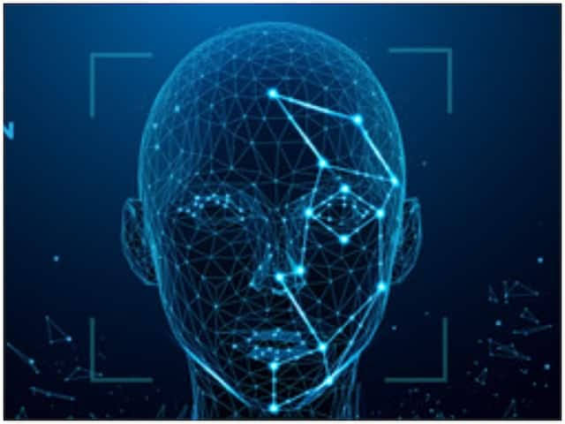

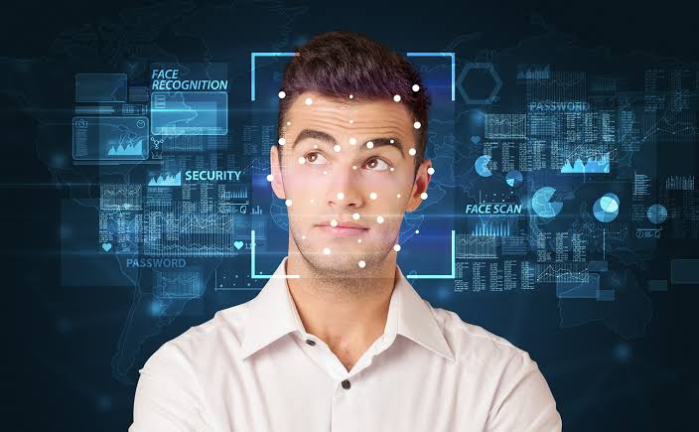

**1.5 Team Organization**

* **Shubham Patel (Team leader):**

Along with doing preliminary investigation and understanding the limitations of current system, I studied about the topic and its scope and surveyed various research papers related to the technology that is to be used. I also worked on the implementation of face detection of face and the working of project. Worked on creating database for storing results in database. Documentation is also a part of the work done by me in this project.

* **Sarvesh Lowanshi :**

I investigated and found the right technology and studied in deep about it. For the implementation of the project , I collected the object data and trained the model for it. Implementation logic for the project objective and coding of internal functionalities is also done by me. Also, worked on front end design for storing results in database for maintaining logs.

* **Shivam chouhan:**

I worked on the technology and implementation of the project , Implementation logic for the project objective and coding of internal functionalities is also done by me.

* **Vikash rawat :**

I worked in front end and I studied about the topic and its scope and searched various research papers related to the technology that is to be used.

**1.6 Report Structure**

The project “**Develop A Smart Attendance Capturing Mobile App.”** is primarily concerned with the attendance and whole project report is categorized into five chapters.

**Chapter 1: Introduction** - introduces the background of the problem followed by rationale for the project undertaken. The chapter describes the objectives, scope and applications of the project. Further, the chapter gives the details of team members and their contribution in development of project which is then subsequently ended with report outline

**Chapter 2: Review of Literature** - explores the work done in the area of Project undertaken and discusses the limitations of existing system and highlights the issues and challenges of project area. The chapter finally ends up with the requirement identification for present project work based on findings drawn from reviewed literature and end user interactions.

**Chapter 3: Proposed System** - starts with the project proposal based on requirement identified, followed by benefits of the project. The chapter also illustrate software engineering paradigm used along with different design representation. The chapter also includes block diagram and details of major modules of the project. Chapter also gives insights of different type of feasibility study carried out for the project undertaken. Later it gives details of the different deployment requirements for the developed project.

**Chapter 4: Implementation** - includes the details of different Technology/ Techniques/ Tools/ Programming Languages used in developing the Project. The chapter also includes the different user interface designed in project along with their functionality. Further it discuss the experiment results along with testing of the project. The chapter ends with evaluation of project on different parameters like accuracy and efficiency.

**Chapter 5: Conclusion** - Concludes with objective wise analysis of results and limitation of present work which is then followed by suggestions and recommendations for further improvement.

**Chapter 2 . Review of Literature**

Review of Literature



Digitalizing the Old Approach Traditional student attendance involves all the roll-calling issues and takes a lot of time for students and teachers to conduct departmental sessions. The procedure is lengthy and takes many instructors’ and students’ time. Mendonca et al. [20] reduced the length of the complete attendance verification by designing an online system. Substituting the conventional procedure, teachers had to call each student’s name in class and note the attendance when the student answered. It offers a more straightforward and quicker approach to monitoring attendance. Instructors will no longer require a paper sheet to mark student attendance in their proposed system. They can construct attendance records by obtaining the necessary information from the database, making the entire procedure paperless. Another Research used mobile devices in the attendance management system were developed and put into practice. A mobile-based attendance management program for Android systems was developed using VB.NET and SQL Server. This project allows for the maintenance of student attendance, calculating attendance grades, and creating a report. Five components make up the system: admin, registration, student, SMS, and an Android component. Students can use the android part to send messages to the system informing lecturers of their absence. Parents can also get SMS notifications on students’ behavior [19]. B. Fingerprint Recognition Based Most of the research has demonstrated that fingerprint or hand gesture recognition is a highly suitable method for an attendance management system. The method of digitally comparing one or more unknown fingerprints to a collection of known and unknown fingerprints in the database is known as automated fingerprint recognition. A particular finger assumption device that is used as a component of a special finger impression attendance framework was described by Mohamed and Raghu [3]. The students may check their essence by placing their fingertips on the device's sensor. But because fingerprint scanners can’t always identify something the first time, this framework lacks viability. Soewito et al. [4] presented an attendance system employing smartphone GPS and fingerprint technologies. The method takes a lot of time since it makes use of fingerprint recognition. Fig. 1 General Architecture of Fingerprint Recognition C. GPS-based Attendance System Global Positioning System, or GPS, enables us to determine a person’s location and direction at any time, any place on Earth. In terms of knowing where humans are and how to go to other areas, people still

**2.1 Preliminary Investigation**

**2.1.1 Current System**

1. Fingerprint Based recognition system:

In the Fingerprint based existing attendance system, a portable fingerprint device need to be configured with the students fingerprint earlier. Later either during the lecture hours or before, the student needs to record the fingerprint on the configured device to ensure their attendance for the day. The problem with this approach is that during the lecture time it may distract of the students.

1. RFID (Radio Frequency Identification) Based recognition system:

In the RFID based existing system, the student needs to carry a Radio Frequency Identity Card with them and place the ID on the card reader to record their presence for the day. The system is capable of to connect to RS232 and record the attendance to the saved database. There are possibilities for the fraudulent access may occur. Some are students may make use of other students ID to ensure their presence when the particular student is absent or they even try to misuse it sometimes.

3. Iris Based Recognition System:

In the Iris based student attendance system, the student will scan the Iris of the student. Retinal scanning is a different, ocular-based biometric technology that uses the unique patterns on a person's retina blood vessels and is often confused with iris recognition. Iris recognition uses video camera technology with subtle near infrared illumination to acquire V the detail-rich, intricate structures of the iris which are visible externally. Digital templates encoded from these patterns by mathematical and statistical algorithms allow the identification of an individual or someone pretending to be that individual.[1] Databases of enrolled templates are searched by matcher engines at speeds measured in the millions of templates per second per (single core) CPU, and with remarkably low false match rates. needs to stand in front of a camera, so that the camera detect the face.

4. Face Based Recognition System:

The facial recognition technology can be used in recording the attendance through a high-resolution digital camera that detects and recognizes the faces of the students and the machine compares the recognized face with students’ face images stored in the database. Once the face of the student is matched with the stored image, then the attendance is marked in attendance database for further calculation. If the captured image doesn't match with the students' face present in the database, then this image is stored as a new image onto the database. In this system, there are possibilities for the camera to not to capture the image properly or it may miss some of the students from capturing.

**2.2 Limitations of Current System**

combines elements of the system planning and systems analysis phases of the Systems Development Life Cycle (SDLC) Users, managers, and IT staff members discuss and agree on business needs, project scope, constraints, and system requirements. It ends when the team agrees on the key issues and obtains management authorization to continue. The main method used in gathering data for this system was online interview.

Personnel that were interviewed include:

. Assistant head of ICT department Some employees

. Network Administrator

**FUNCTIONAL REQUIREMENTS**

⚫ System must capture faces

System must store faces in a DB attached to the employee's ID System must recognize the employee to enable attendance marking

**NON-FUNCTIONAL REQUIREMENTS**

System shall be error-free

⚫ System shall operate in real-time

⚫ System should prevent data manipulation

⚫ System should have a maximum uptime

**2.3.1 Conclusion**

Automated attendance systems are more efficient than manual systems as it prevents employees from falsifying entireties’

**RECOMMENDATION**

For the purpose of ICT growth that will lead to a rich , efficient , and result driven mode of attendance in NIPLC , we recommend that the face recognition algorithm should be used in order to enhance the e - attendance system .

**PERSONAL EXPERIENCE**

The project really helped to sharpen our programming skills and SQL querying. It served as a tough challenge as writing algorithms for face detection and recognition was a huge step from our previous knowledge. It also gave an insight to our short comings and abilities.

**FUTURE RESEARCH DIRECTIONS**

The project is just a blueprint for implementing a full functional e - attendance system. After this blueprint, a thorough research should be carried out on this system, laying more emphasis on the impact it has on attendance and how it has enhanced company's employee – hour output the impact that this system has on the business sector should be studied and compared to that of the manual system.

**Chapter 3 . Proposed System**

Proposed System



**3.1 The Proposal**

The proposal is to make a application that plays a very important role in making applications available to the people of your area. If your app can detect the face and marked the proper attendance. As accessibility increases, the popularity of the application will too.

**3.2 Benefits of the Proposed System**

The current system had a lot of challenges that are overcome by this system :

All the employees of the company must register themselves by entering the required details and then their images will be captured and stored in the dataset. During each shift’s, faces will be detected in company. The faces detected will be compared with images present in the dataset. If match found, attendance will be marked for the respective employee. The system architecture of the proposed system is given below,

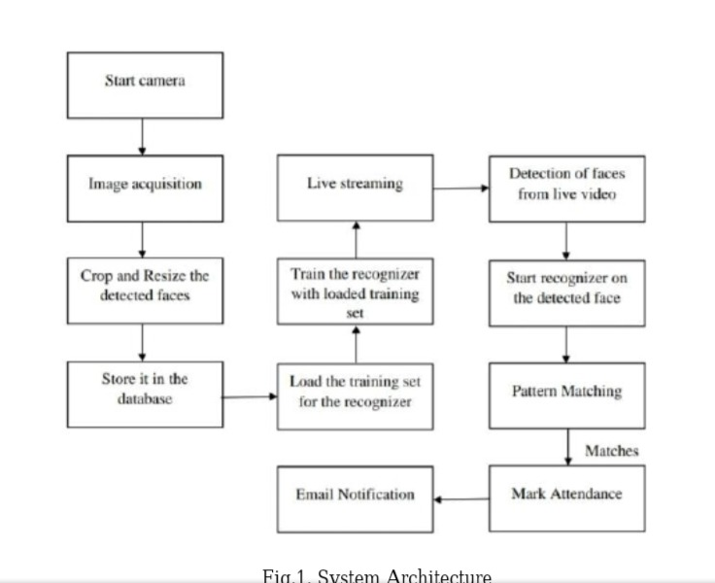

Typically this process can be divided into four stages,

**1. Dataset Creation**

Images of employees are captured using a web cam. Multiple images of single employee will be acquired with varied gestures and angles. These images undergo pre-processing. The

images are cropped to obtain the Region of Interest (ROI) which will be further used in recognition process. Next step is to resize the cropped images to particular pixel position. Then these images will be converted from RGB to Gray scale images. And then these images will be saved as the names of respective student in a folder.

1. **Face Detection**

Face detection here is performed using Haar-Cascade Classifier with OpenCV. Haar Cascade algorithm needs to be trained to detect human faces before it can be used for face detection. This is called feature extraction. The haar cascade training data used is an xml file-haarcascade_frontalface_default. The haar features shown in Fig.2. will be used for feature extraction. Here we are using detect Multi-Scale module from OpenCV. This is required to create a rectangle around the faces in an image. It has got three parameters to consider- scale Factor, Min Neighbour’s, min Size. Scale Factor is used to indicate how much an image must be reduced in each image scale. Min Neighbour’s specifies how many neighbours each candidate rectangle must have. Higher values usually detect less faces but detects high quality in image. minSize specifies the minimum object size. By default, it is (30,30) [8]. The parameters used in this system is scale Factor and minNeighbors with the values 1.3 and 5 respectively.

3. Face Recognition

Face recognition process can be divided into three steps-

prepare training data, train face recognizer, prediction. Here training data will be the images present in the dataset. They

will be assigned with a integer label of the student it belongs to. These images are then used for face recognition. Face recognizer used in this system is Local Binary Pattern Histogram. Initially, the list of local binary patterns (LBP) of entire face is obtained. These LBPs are converted into decimal number and then histograms of all those decimal values are made. At the end, one histogram will be formed

for each images in the training data. Later, during recognition

process histogram of the face to be recognized is calculated

and then compared with the already computed histograms and

returns the best matched label associated with the employee it

belongs to [9].

1. Attendance Updation

After face recognition process, the recognized faces will be marked as present in the excel sheet and the rest will be marked as absent and the list of absentees will be mailed to the respective faculties. Manager will be updated with monthly attendance sheet at the end of every month.

**UML Diagrams**

**ER diagram**

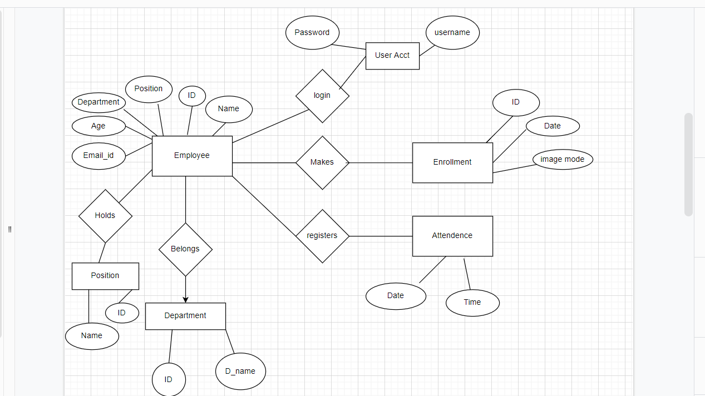

***Class diagram***

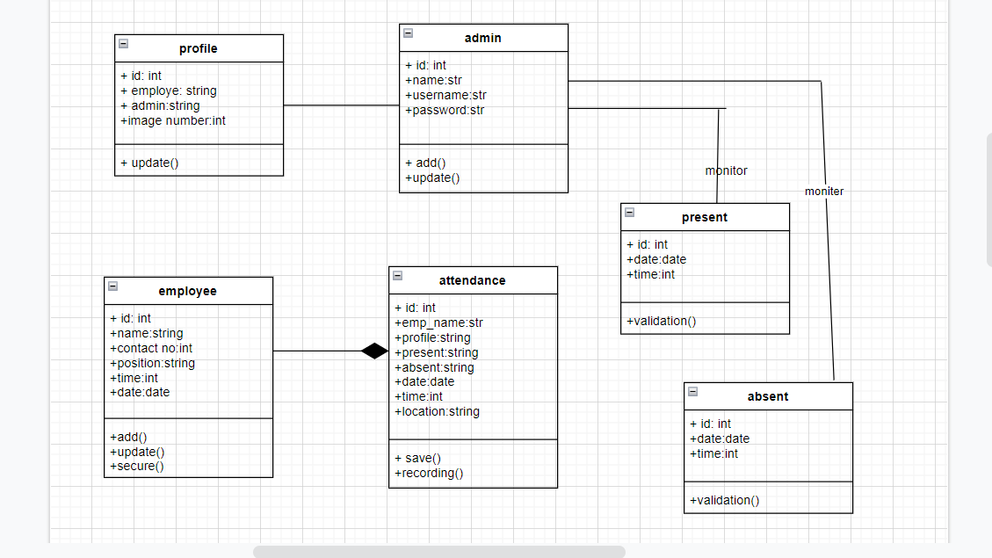

***Data flow diagram***

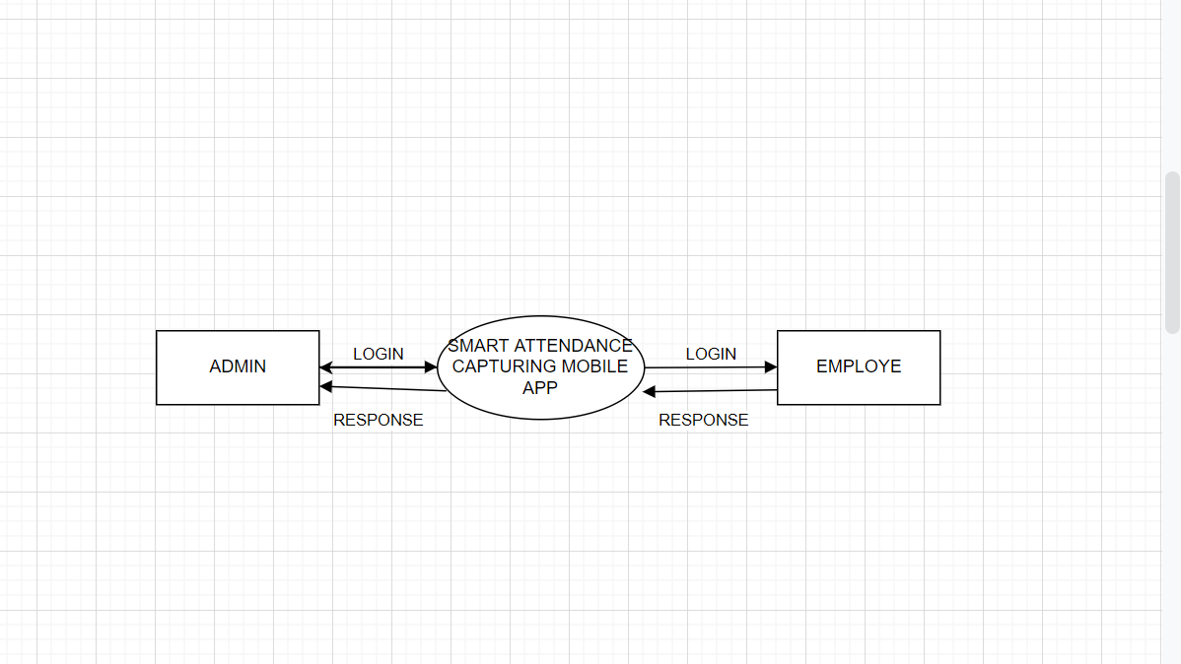

***Flow chart***

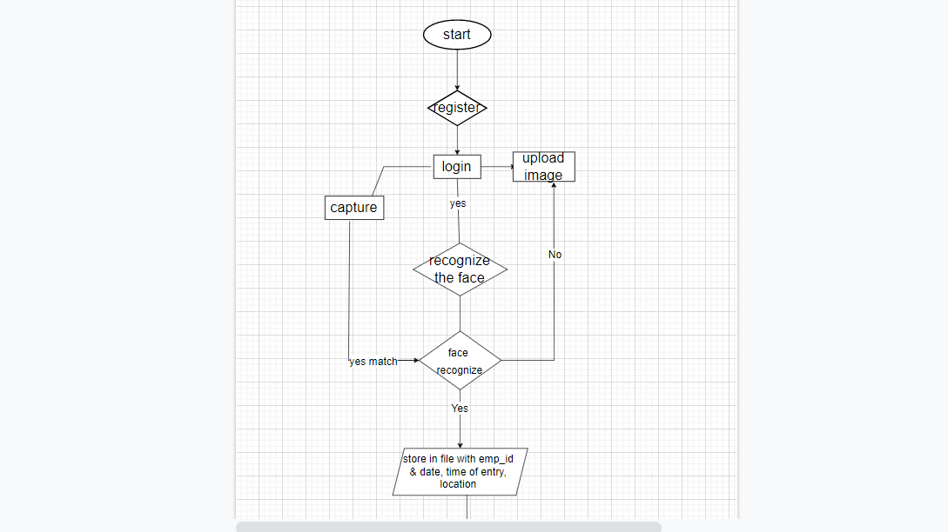

***Level diagram***

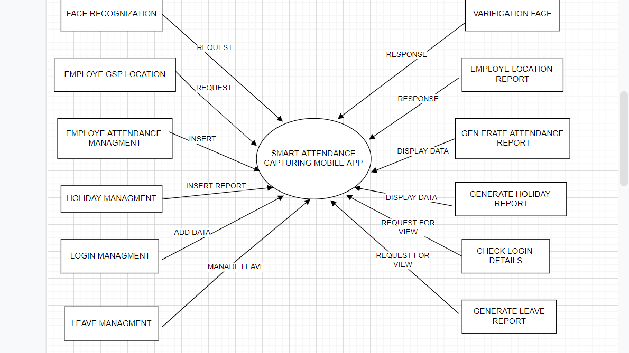

**Chapter 4 . Implementation**

Implementation



For the problem of counting the number of students and vehicles entering the college campus manually, the system is designed in such a way so as to automate the process by placing a camera at the entrance gate so that students, bikes and cars getting inside the college campus can be identified and counted.

**Screenshot are:-**

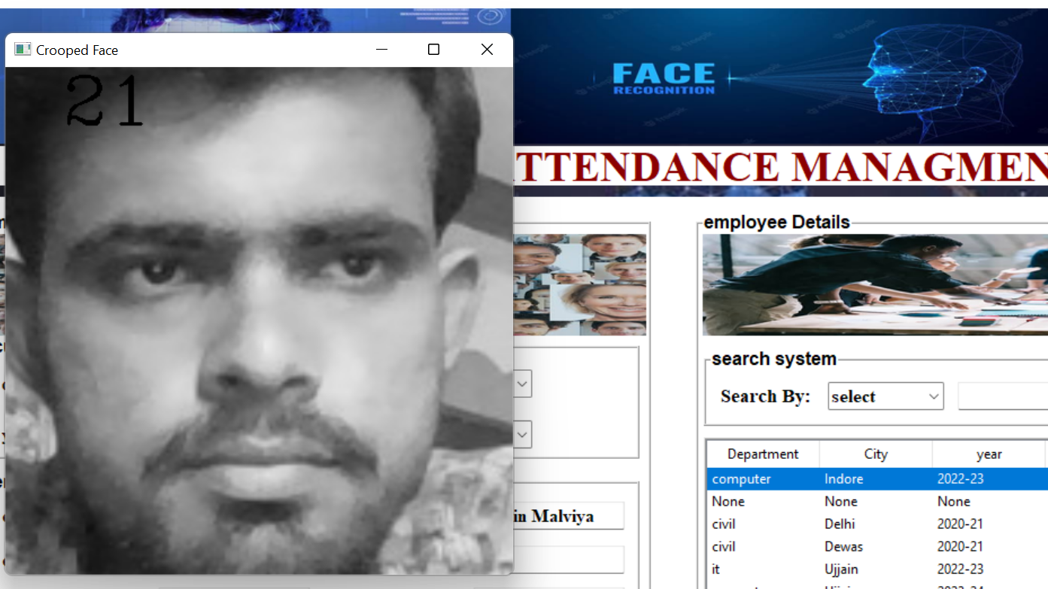

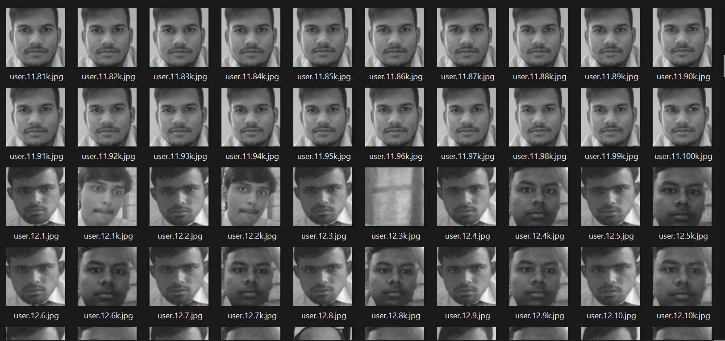

**4.5 Testing**

Testing is the process of evaluation of a system to detect differences between given input and expected output and also to assess the feature of the system. Testing assesses the quality of the product. It is a process that is done during the development process. .

**4.5.1 Strategy Used**

Tests can be conducted based on two approaches –

* Functionality testing
* Implementation testing

The texting method used here is Black Box Testing. It is carried out to test functionality of the program. It is also called ‘Behavioral’ testing. The tester in this case, has a set of input values and respective desired results. On providing input, if the output matches with the desired results, the program is tested ‘ok’, and problematic otherwise.

**Chapter 5.Conclusion**

Conclusion



**5.1 Conclusion**

This system aims to build an effective company attendance system using face recognition techniques. The proposed

system will be able to mark the attendance via face Id. It will detect faces via webcam and then recognize the faces. After recognition, it will mark the attendance of the recognized employee and update the attendance record.

**5.2 Limitations of the Work**

* It will not include Gps location system now.
* It will not include the future that everyone can marl the attendance by photo also.

**5.3 Suggestion and Recommendations for Future Work**

* The Model would be trained for detecting more number of employees in less time.
* Employe would not be give fack attendance due to gps location.
* Further we give a future that detector can be present physically on company

**Bibliography**

http://www.fhi.gov/about-us ciis fingerprints hiometrics biometric-center-of

excellence/modalities/facial-recognition Computer vision based employee.pdf

Available: https://www.google.com.ng/url?

*63 Sequence=1&ei=CYWUusMazh7Aawy4HICOAFOCNEMIA FARO

yMtMgTG2w&sig=3u7 DZufmm4NYP+9JIMw

**Guide Interaction Sheet**



|  |  |  |
| --- | --- | --- |
| **Date** | **Discussion** | **Action Plan** |
|  |  |  |
|  | Discussed about the title of the | Attendance capturing App. |
| 1/08/2022 |  |
| Project |
|  |  |
|  |  |
|  |  |  |
| 03/08/2022 | Discussion on the technology to be | Visual studio and mysql workbench and |
|  | used for marking the attendance . | other tools were finalized |
| 17/08/2022 | Discussion of the creation of | Gathering of information for |
|  | synopsis of the project | synopsis creation |
|  |  |  |
|  | Suggestions on how to do a literature | Many research papers were |
| 27/08/2022 | survey and preliminary investigation | read , understood and their |
|  | on the topic | abstract were to be written. |
|  |  |  |
|  | Discussion on the implementation of | Using face detection and other |
| 12/09/2022 | tools, we decided to |
|  | the project | implement detection. |
|  |  |
|  |  |  |
|  | Discussion on the objective of the | Decided to Include the logic |
| 29/09/2022 | project | Making gps location on it |
|  |  |  |
|  |  |  |
|  | Scope for the project. | Took steps for adding and |
| 10/10/2022 |  | Modifying the application. |
|  |  |  |
|  |  |  |
|  | Worked on database. | Action taken that for each |
|  | user an entry must be made |
| 24/10/2022 |  |
| in the database so that count |
|  |  |
|  | can be made easy |
|  |  |
|  |  |  |
|  |  | Decided to write the content |
| 15/11/2022 | Discussion on project documentation | and integrate it in the proper |
|  |  | fomat of the report |
|  |  |  |